* An intro to Adobe Premier Pro Cs3.
* What are sequence?
* Using a particular resolution.
* Reset the workspace again.
* Organizing the Media.
* Edit the columns to organize your Folder View
* Importing different video and audio formats into Premier Pro.
* Scale to Frame Size.
* 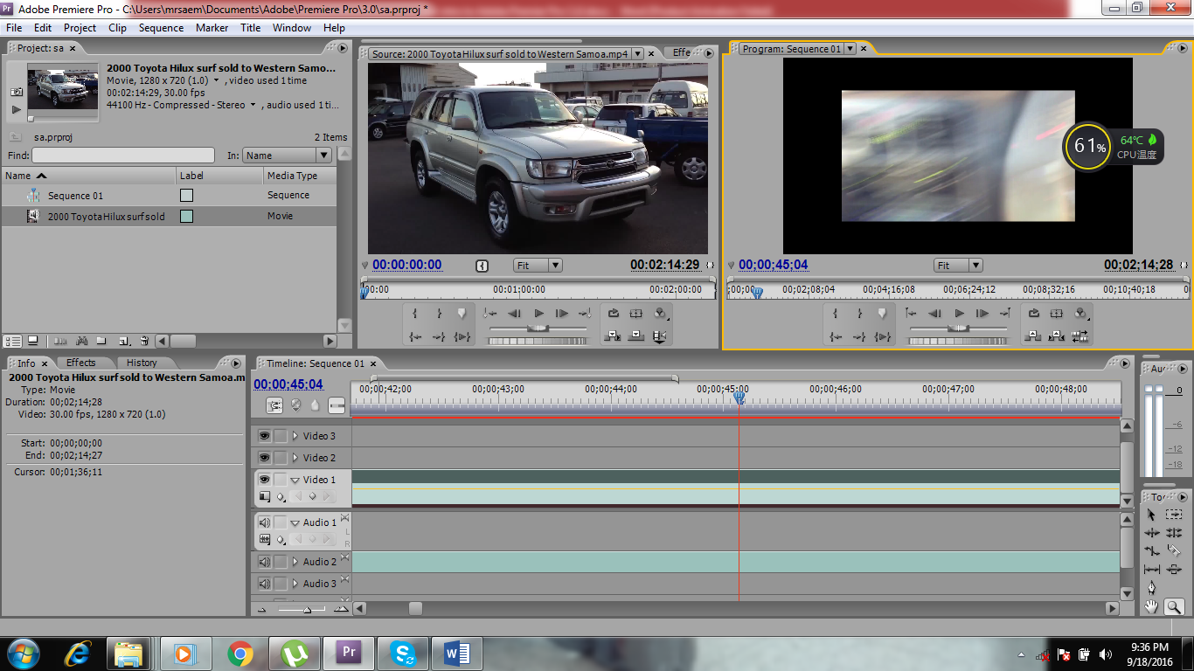Zoom In and Out of the Timeline.
* Setting the time on the timeline.
* Splitting and Video and An audio.
* Increasing and decreasing the volume
  + Use the Home Key to come back to the beginning of the movie.
  + The Razor Tool.
  + The Pick tool.
* Creating your first Movie Title.
* Adding a background image/photo to your title.
* Use the tilde key to maximize the Program Monitor window.
* Using the In and out Points.
* Using the Trim Monitor in the Program Monitor Window.